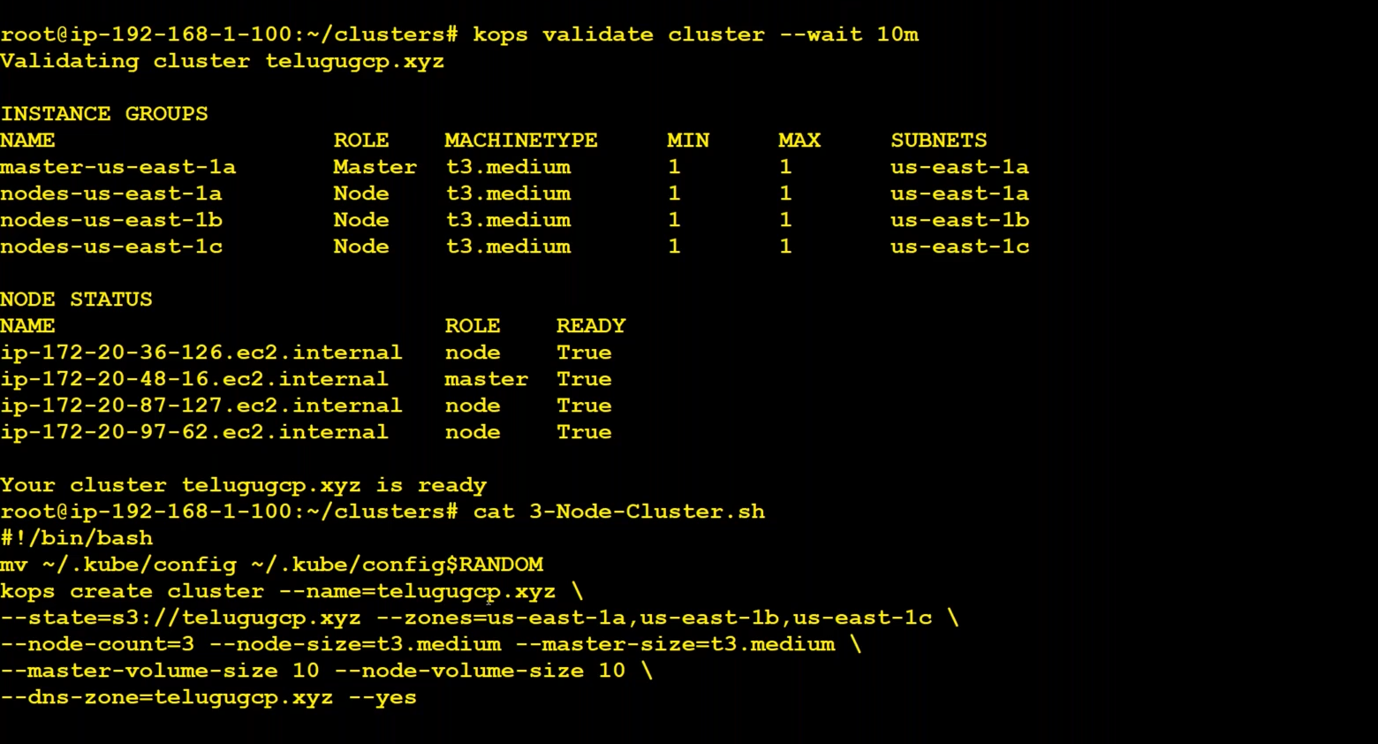

**How to assign a shortcut for kubectl and other words?**

cat ~/.bashrc

add alias ku=kubectl

**PODS:**

It’s a wrapper which can contains multiple containers and volumes

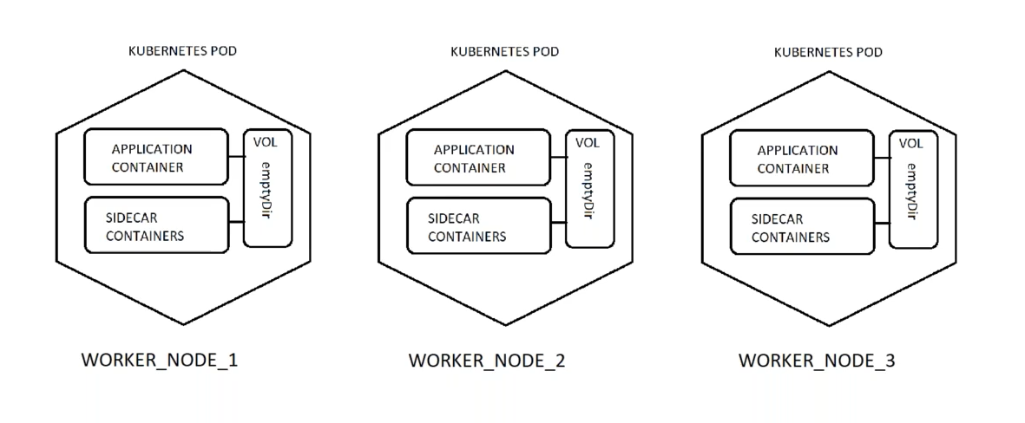

Each POD consists of Appiication container and it can have SIDECAR CONTAINERS also.

Each POD contains a Volume. It’s an empty directory. All the containers in the POD are attached to Volume.

Each POD is in separate server/worker_node

We cam create a POD/Kubernetes Resource in two ways:

1. Using Kubectl cli or imperative
2. Using Kubectl with YAML Manifest or declarative

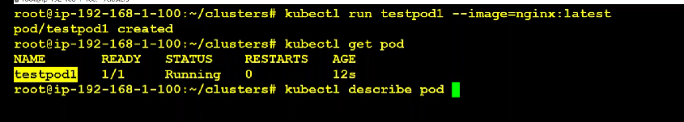

>> kubectl describe pod <podName>

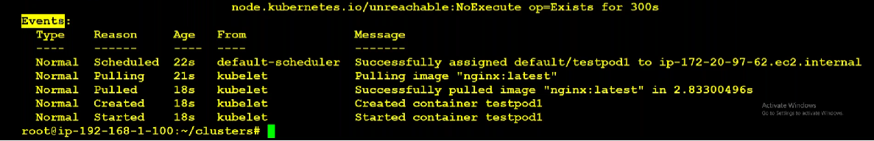

From above snapshot -- scheduler assigns the pod to worker node, kubectl which is running on worker node pulls the image, create the container, start it.

POD Lifecycle : (Interview questions)

<https://kubernetes.io/docs/concepts/workloads/pods/pod-lifecycle/>

To connect to a POD/Application, we need services.

We can use port-forward also to connect to a pod/Application.

<https://phoenixnap.com/kb/kubectl-port-forward>

How to go into the POD which is running:

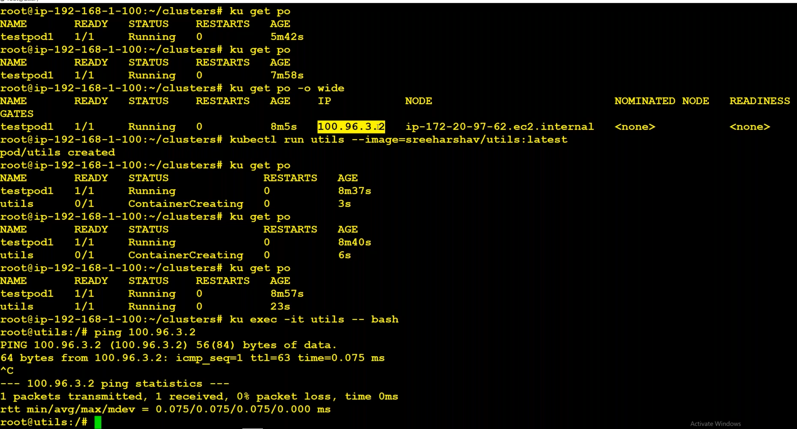

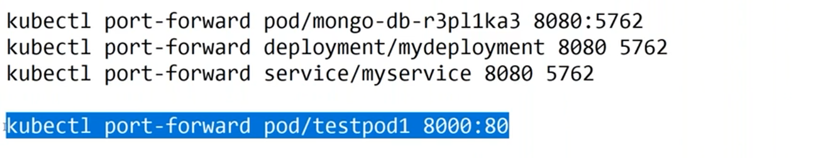

We can do port-forward for pod/deployment/service.

Video – 5 – 24:00 : How to connect from powershell with kubeconfig file ?

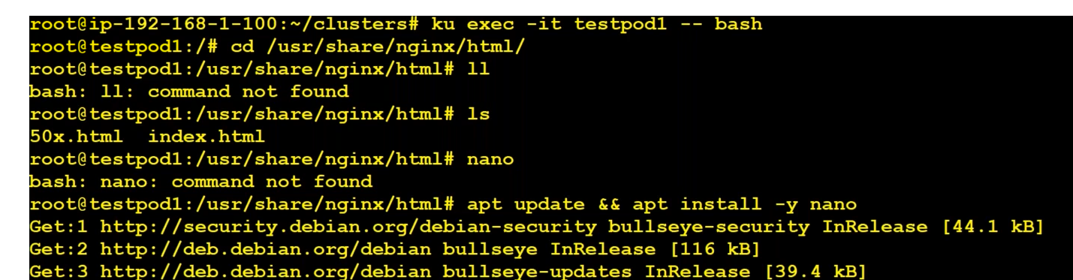

How to use kube port forwarder ?

<https://www.electronjs.org/apps/kube-forwarder>

How to create a pod in declaration/YAML format if we have given an image ?

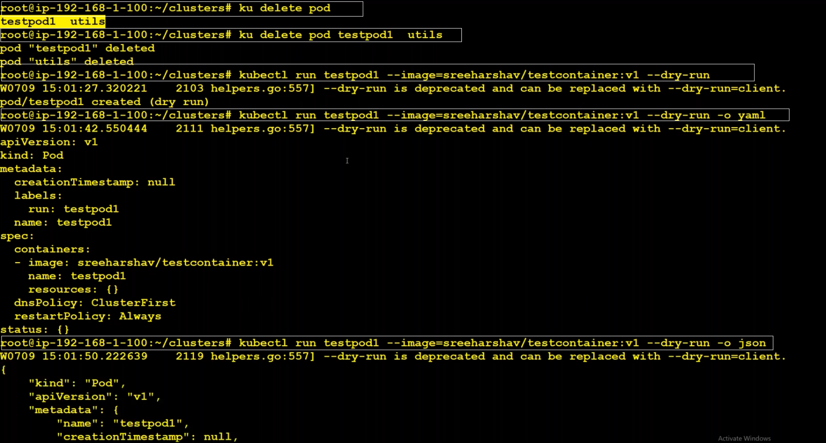

Copy the content of yaml file and remove the unwanted things.

One of the best practice while creating pod via yaml file is to specify the **resources** that we need. Pod will be created if the requested resources like memory and cpu are available in the worker_node/server.

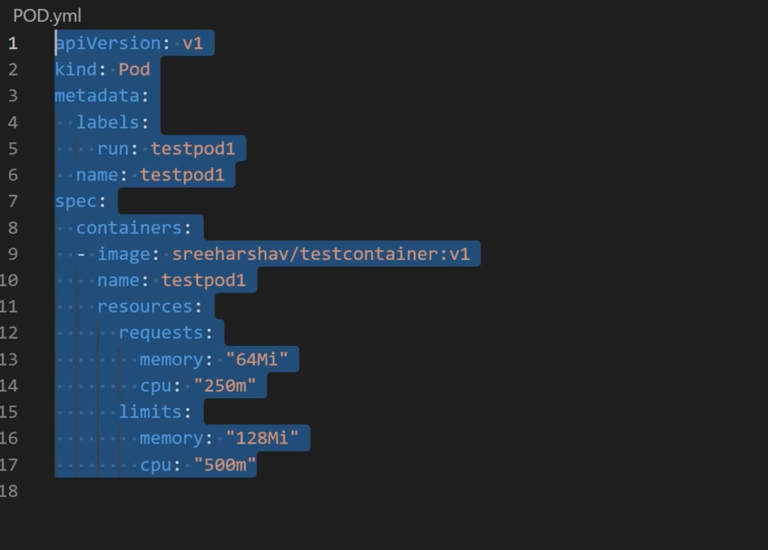

Usually people create pod like this from Yaml file:

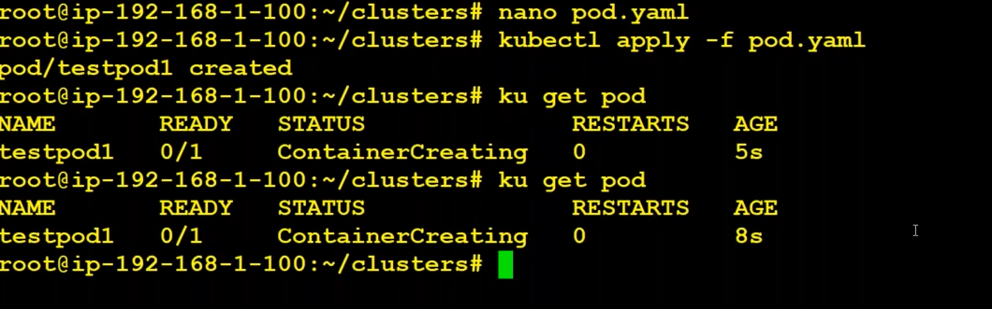

Professional do like below :

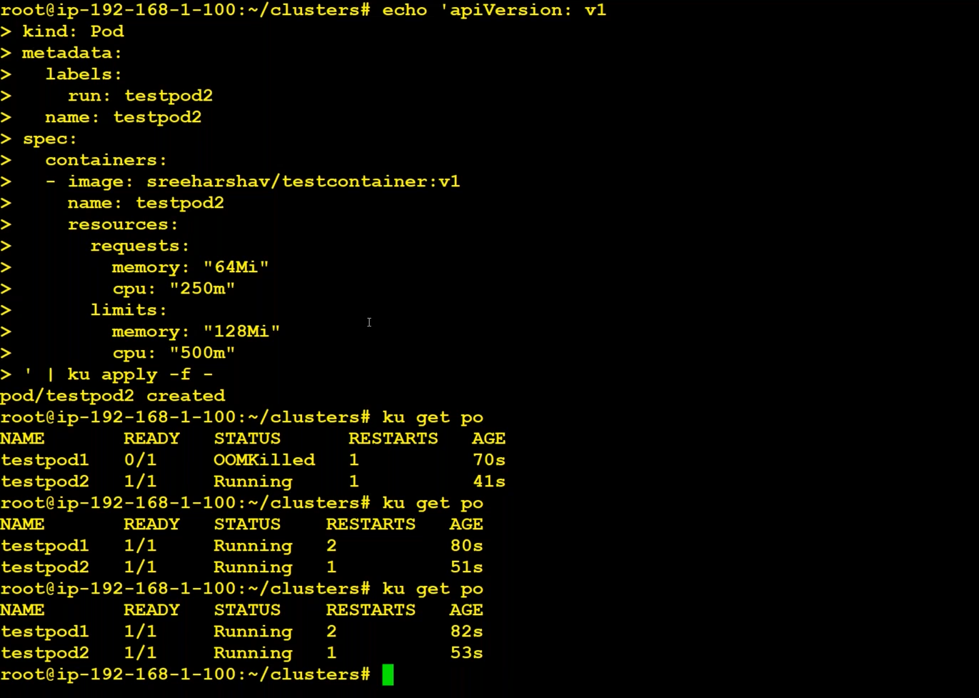

OOMKilled means Out Of Memory Killed. This is because of insufficient memory.

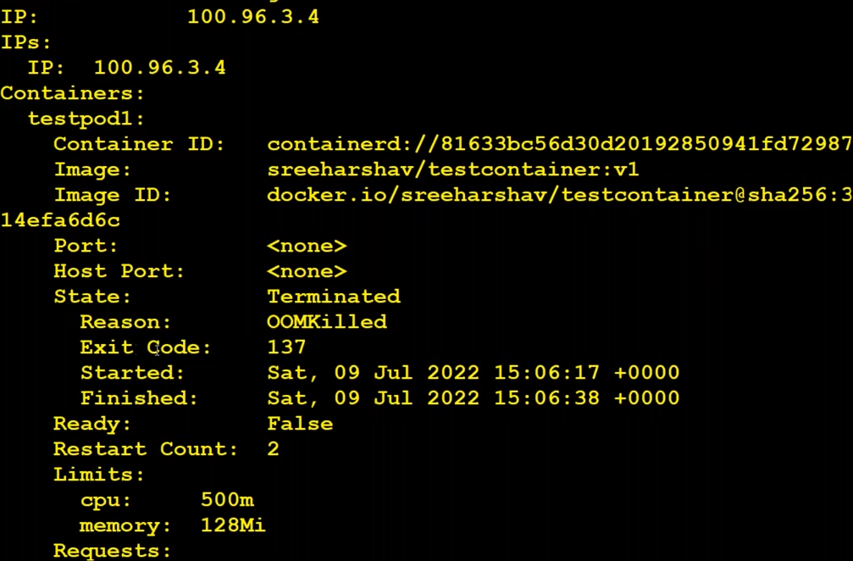

Process get starts but while creating it uses 128mb. So it goes into crashloop after sometime.

After sometime they move into

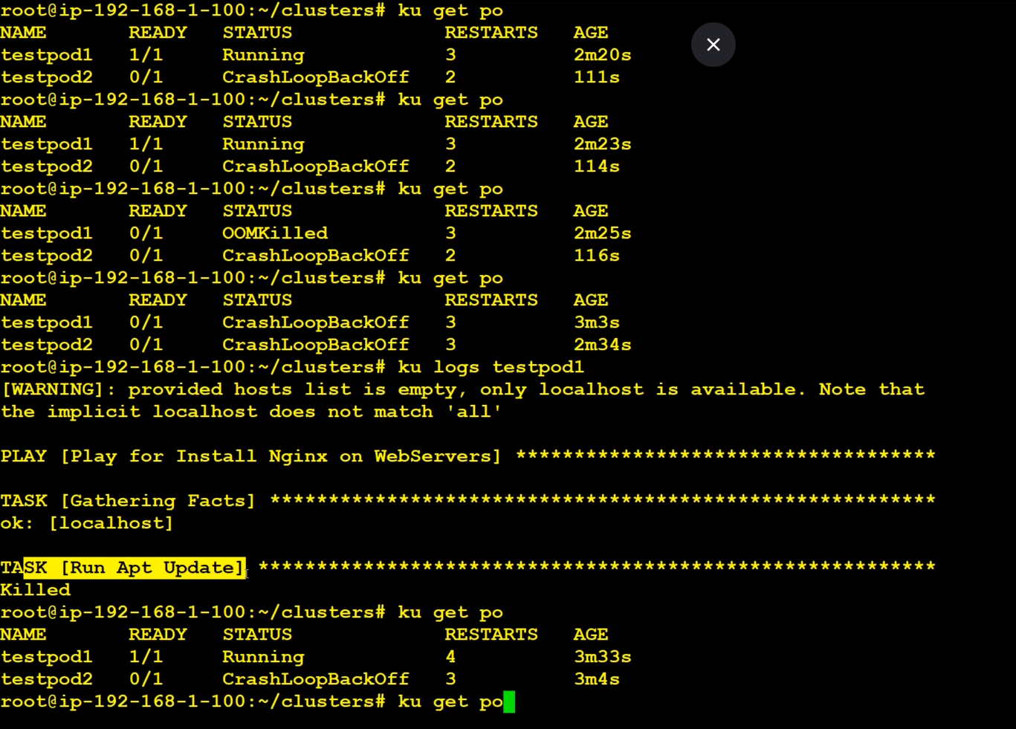

OOMKilled – Out of Memory Killed because if the given memory is not there.

I goes into running state and then again it moves into OOMKilled and then into CrashLoopBackOff

To delete a pod:

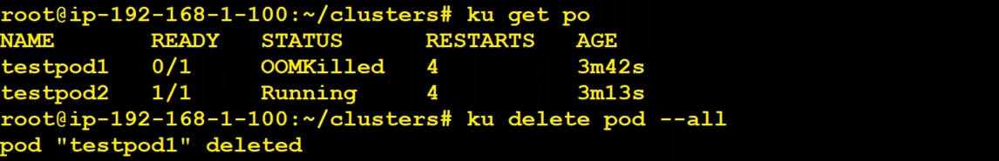

To resove OOMKIlled and CrashLoop, just increase the memory and limits

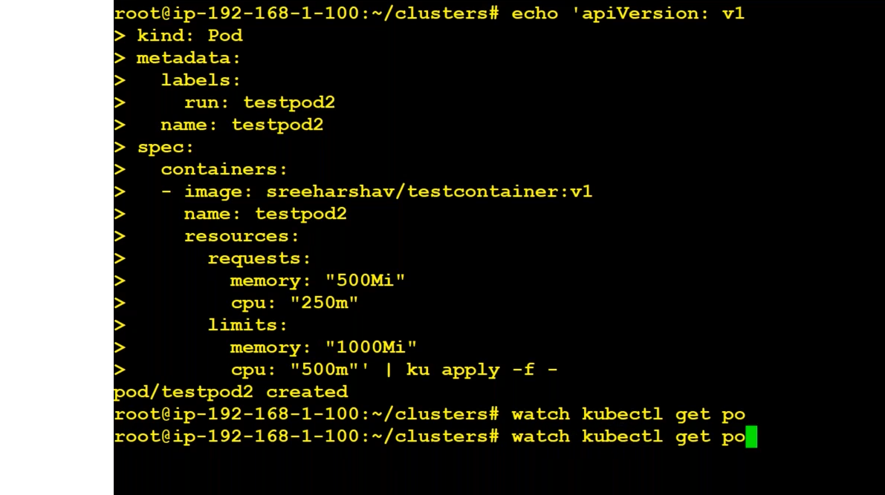

[continues…pic below]

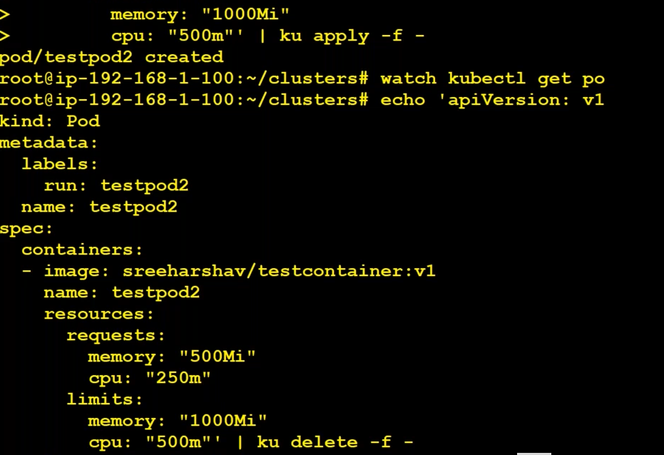

We can delete pod in the above way also.

How to know the exposed port of an application in docker image ?

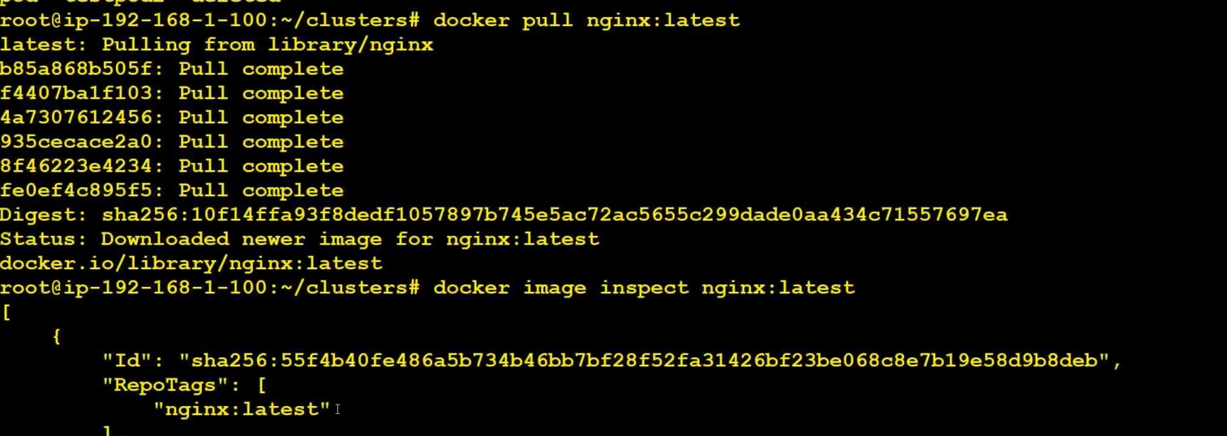

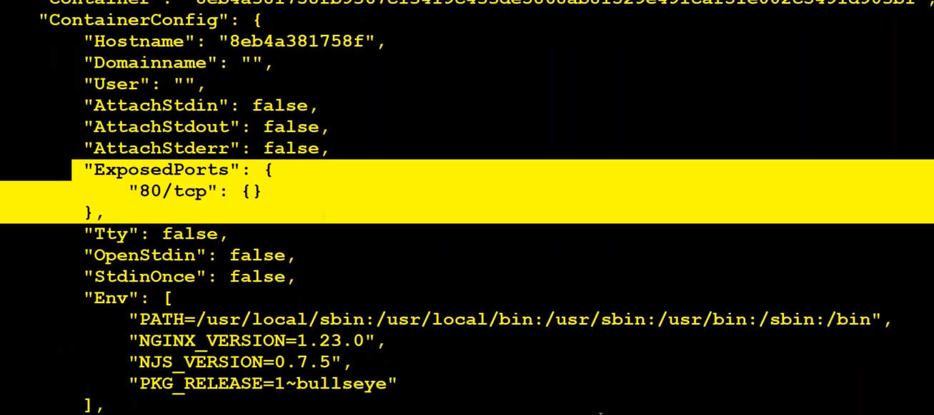

How to check which POD is on which worker ?

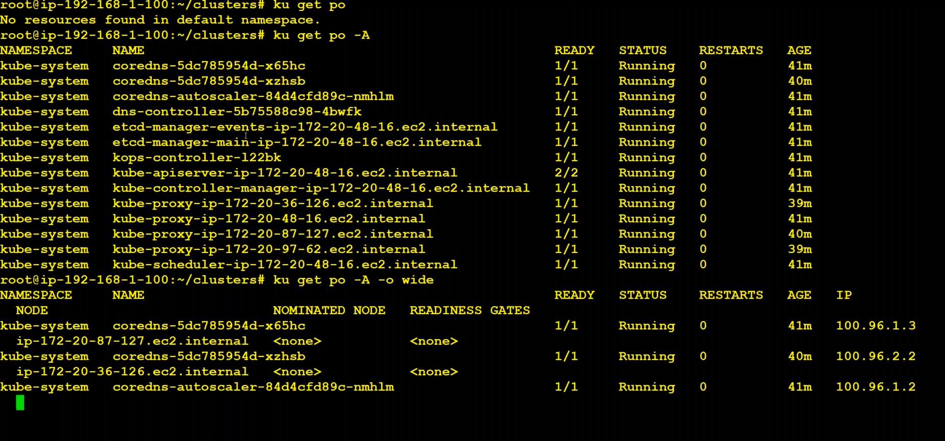

When we try to create a pod first it goes to etcd and then goes to scheduler and then goes to worker node.

How to create a POD without API Server ? **static pods**

Video – 5 : 48:30

ReplicaSet:

<https://kubernetes.io/docs/concepts/workloads/controllers/replicaset/>

The primary responsibility of replica set is making sure that desire number of PODS are running.

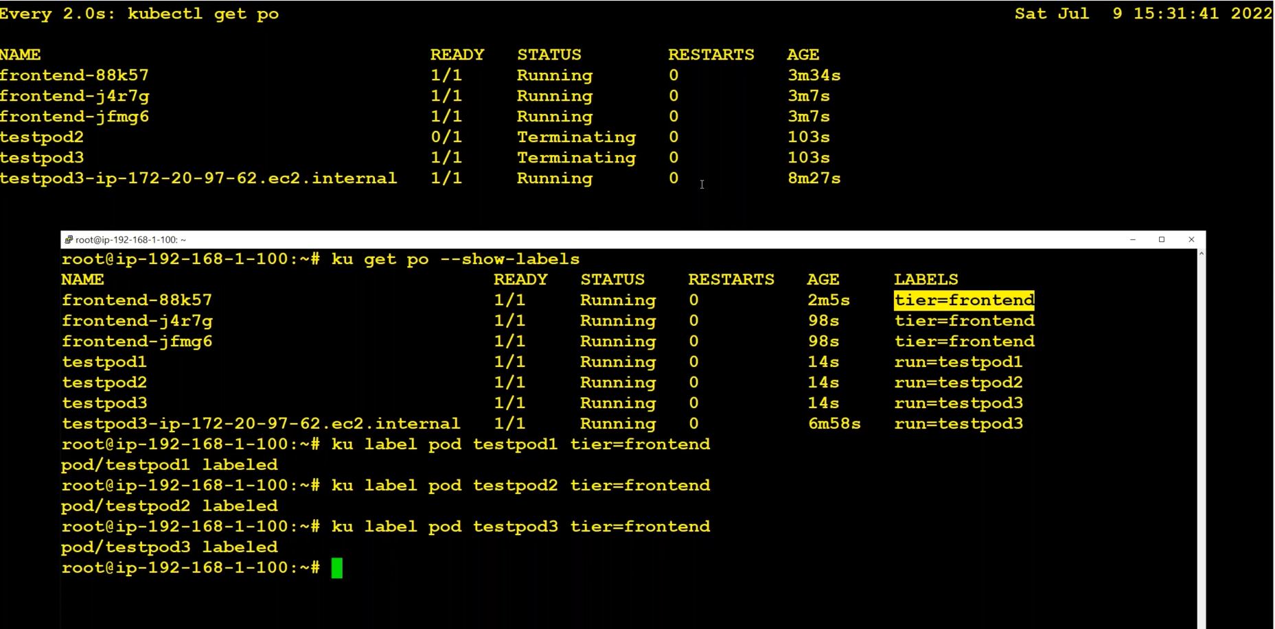

Labels are most important parts of Kubernetes

If we change the label of testpod1, then replicaset notices that one more pod is running with the same label.

As it requires only 3, it removes one of the pods

Replicaset runs a loop to check whether the given pods are there or not. If any pod is down due to some reasons, it creates a new pod.

Delete replicaset:

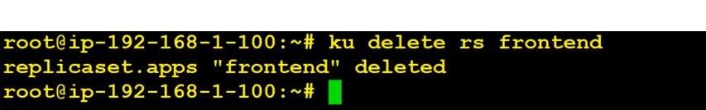

Limitations :

After creating a replica set, then if we want to change the image with is running inside those pods. Then we have to delete the pods running. We could not update the image without deleting the pods.

So, we go with Deployments.

RS vs RC(ReplicationController) :

<https://blog.knoldus.com/replicationcontroller-and-replicaset-in-kubernetes/>

The replication controller supports equality based selectors whereas the replica set supports equality based as well as set based selectors.

Deployments:

Whenever there is change of an imagei n manifest file, deployments can update pods automatically. But Replicaset could not update pods.

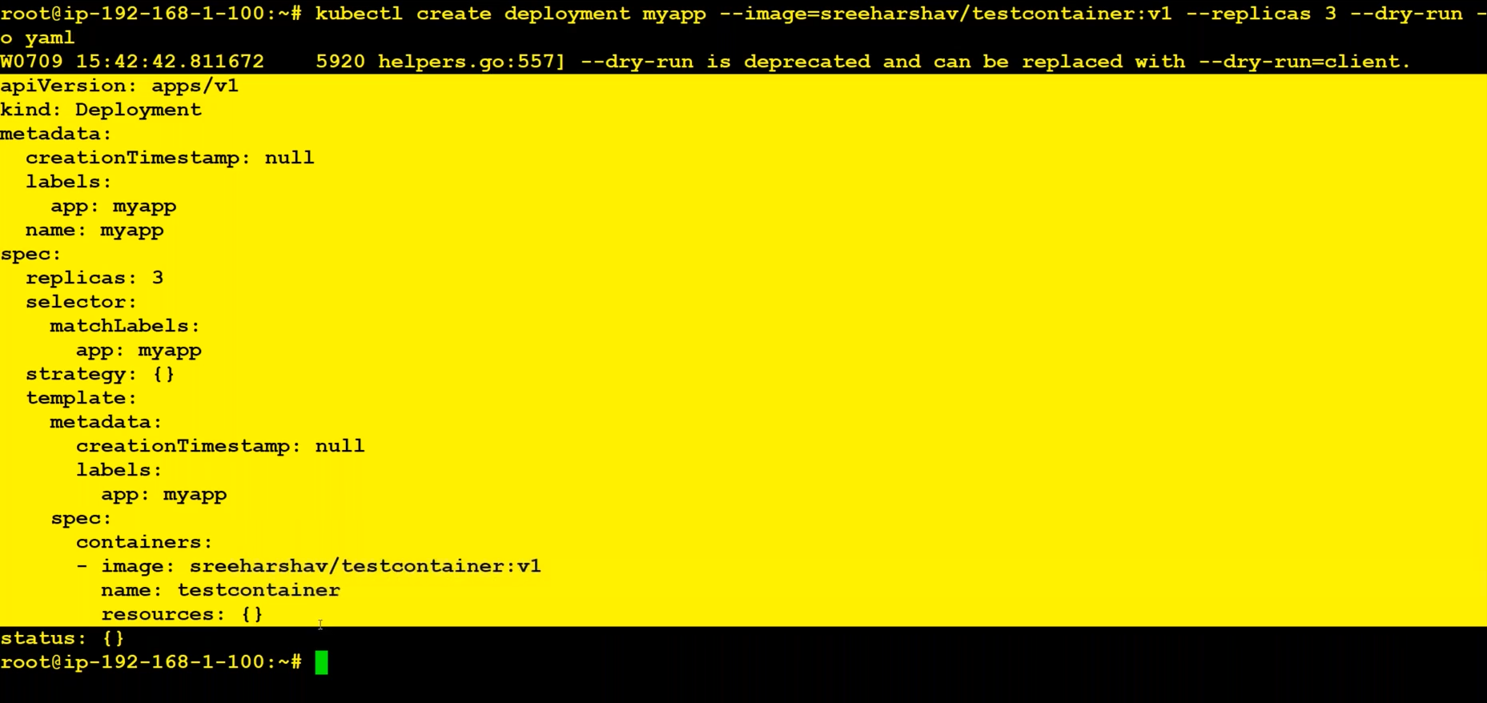

Copy the dry-run result and and pipe symbol and run the command it will create a deployment.

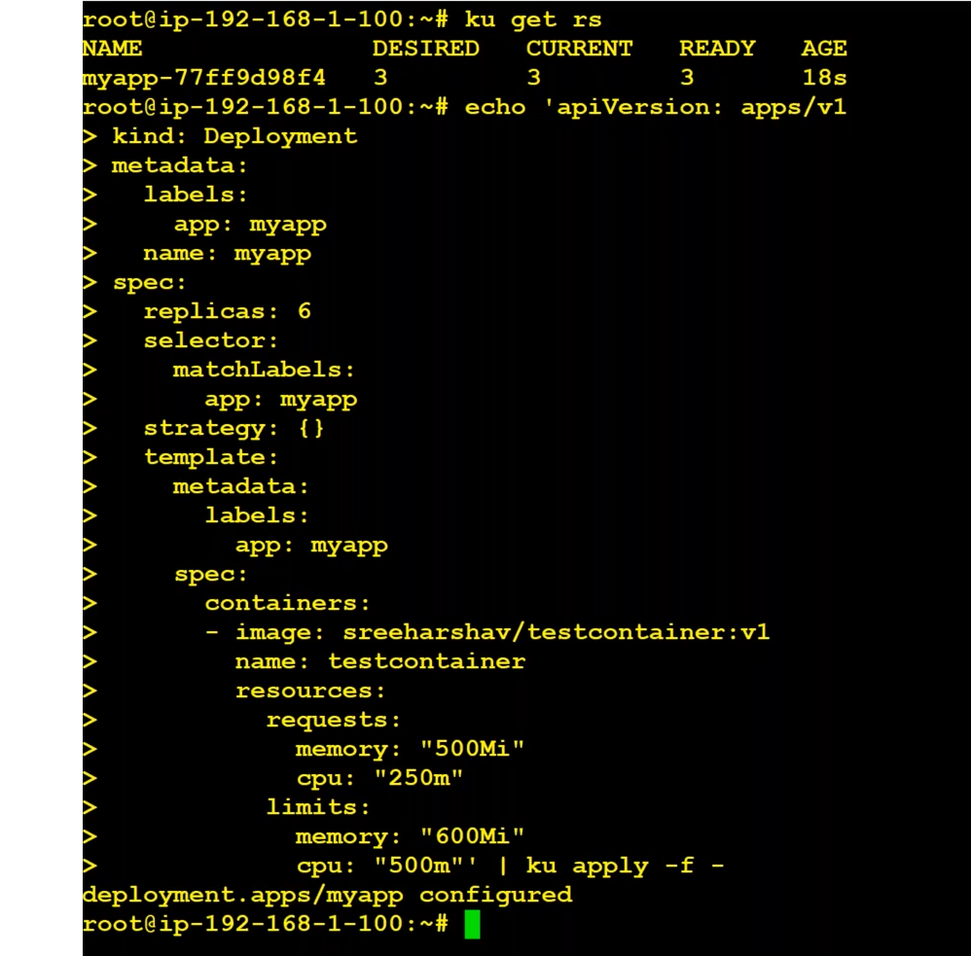Name of the deployment contains the <deployment-name>-<replicaset-name>-<pod-name>

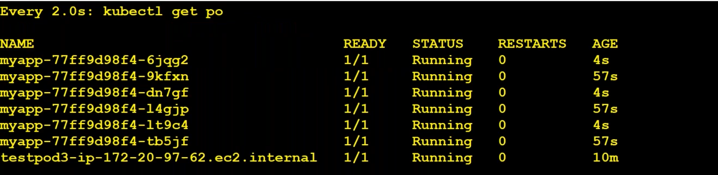

Another way of editing the replicas :



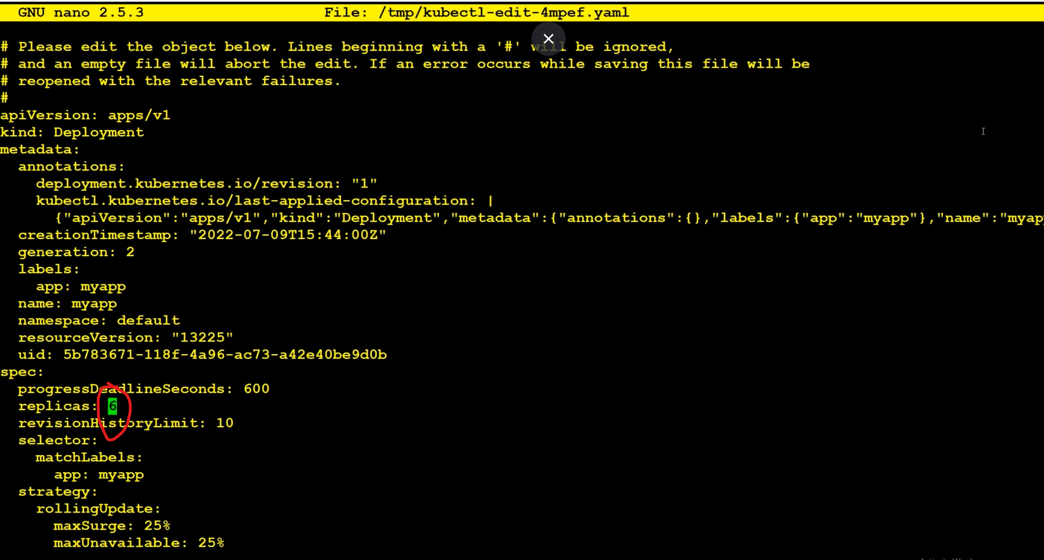

We can edit the above replicas and then save it. It will automatically create the pods.

Port forwarding:

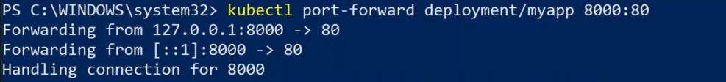

Delete a deployment :

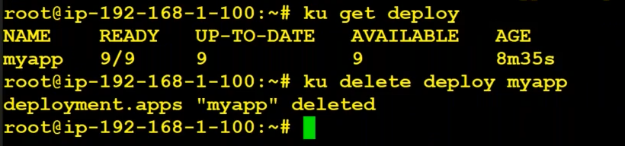

If we change the image in manifest file, then all pods will be terminated and creates new pods at the same time.

Tha’s not the good practice. We need to terminate two pods then two pods and then two pods. That called **rolling update.**

We have to update strategy object in manifest file.

maxSurge and maxAvailable :

<https://kubernetes.io/docs/concepts/workloads/controllers/deployment/>

maxSurge:

.spec.strategy.rollingUpdate.maxSurge is an optional field that specifies the maximum number of Pods that can be created over the desired number of Pods.

<https://phoenixnap.com/kb/kubernetes-rolling-update>

* **maxUnavailable** declares the maximum number (or percentage) of unavailable pods during the update. If **maxSurge** is set to **0**, this field cannot be **0**.

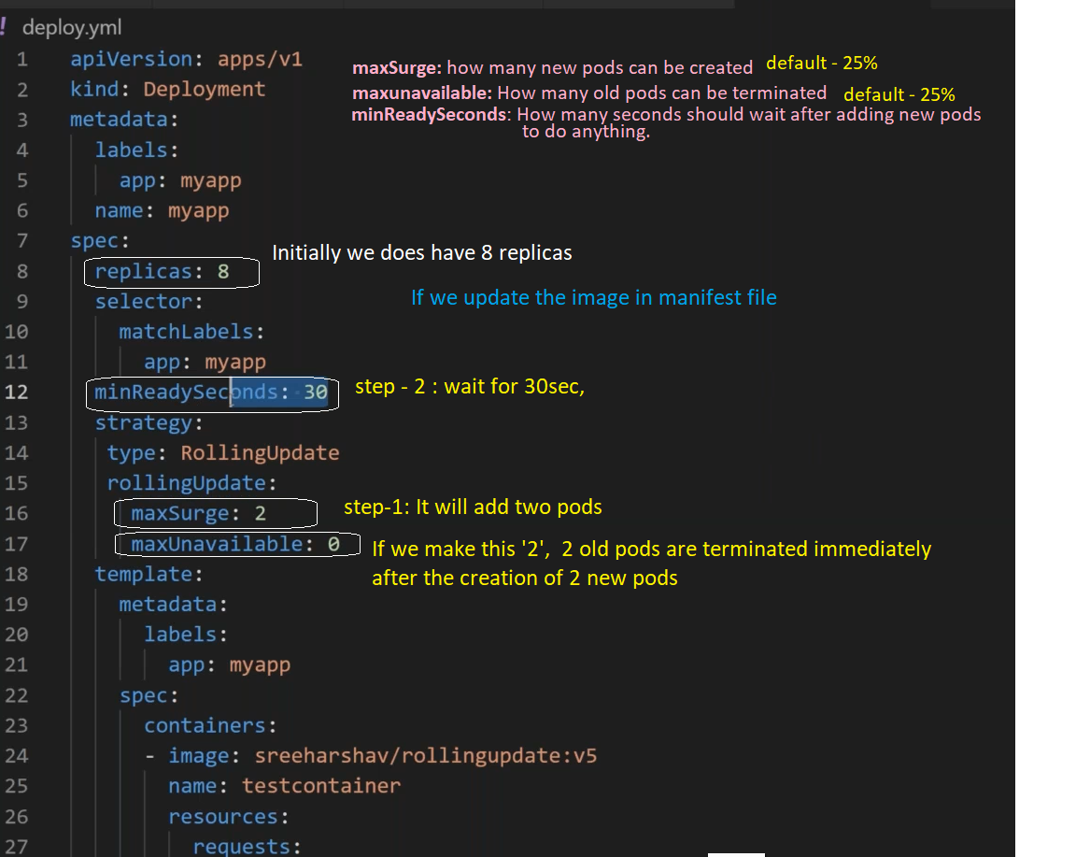

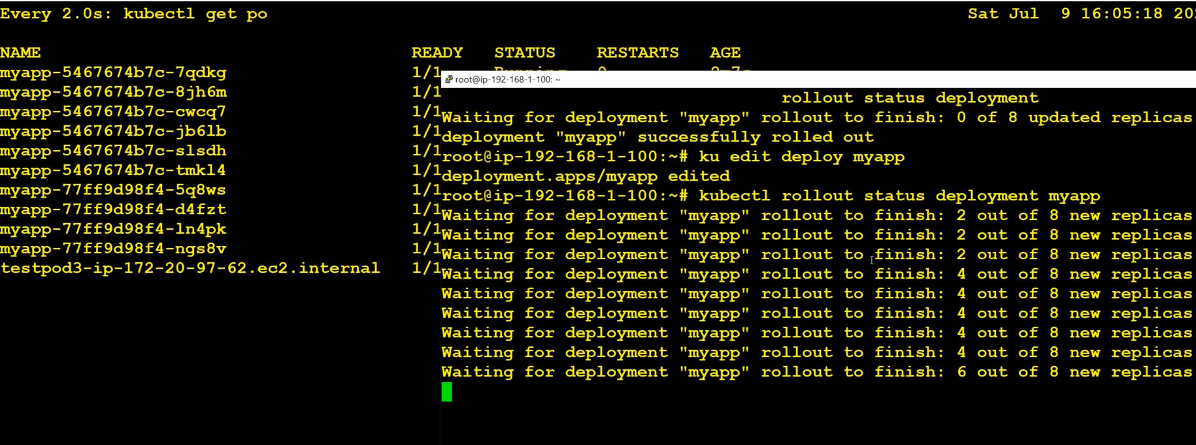

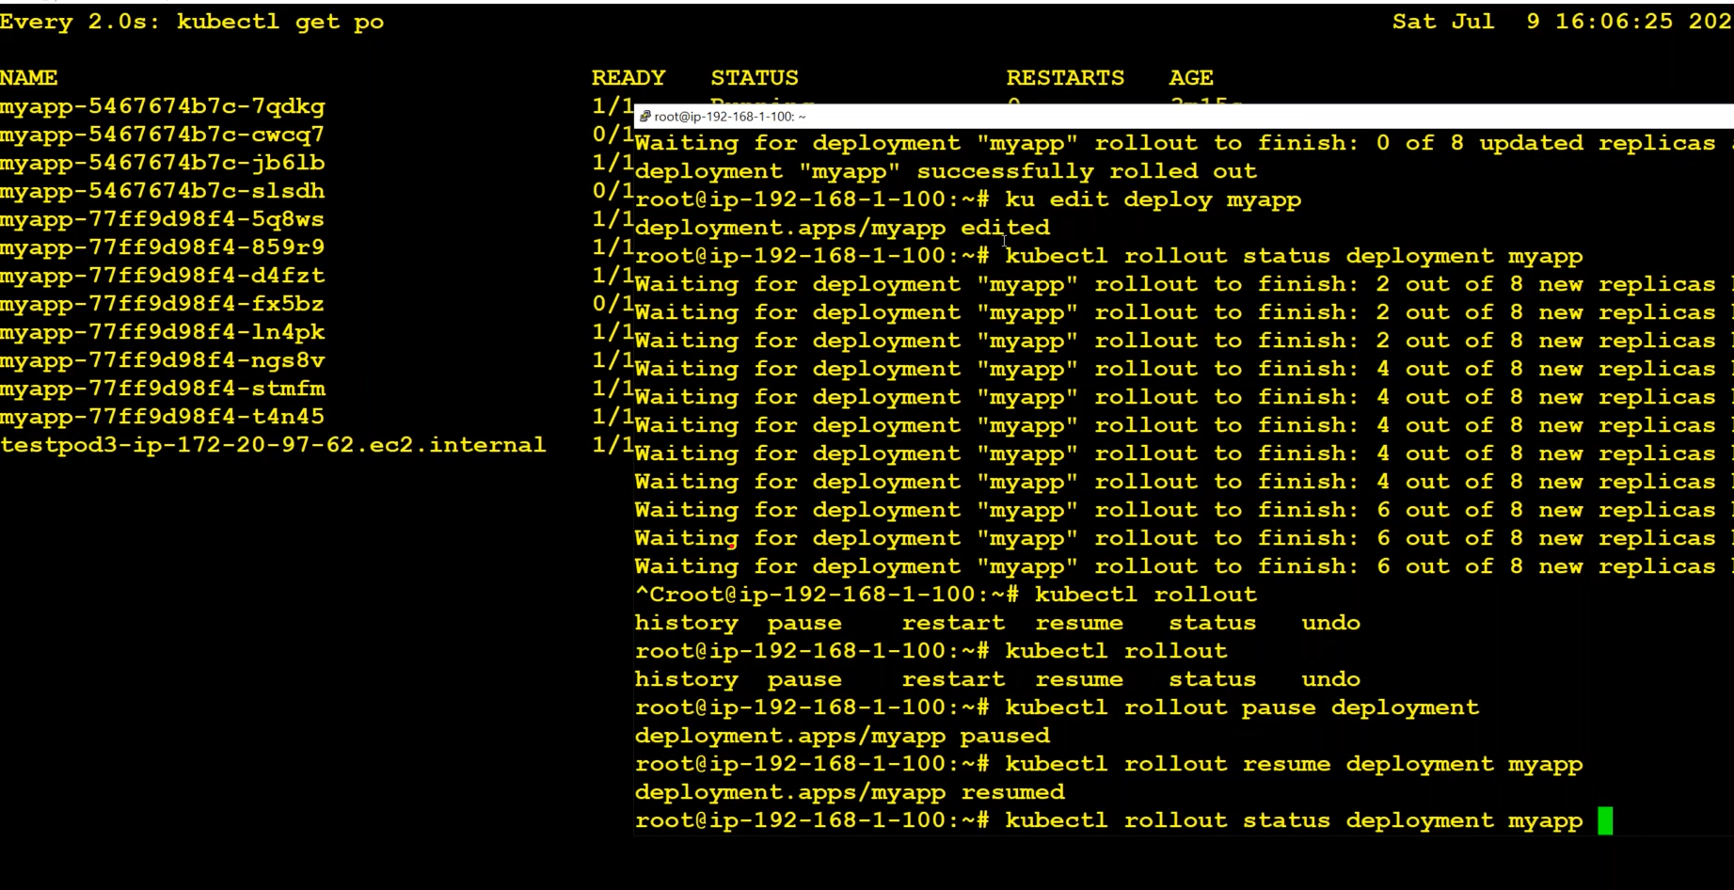

We can abort/pause/resume the rollout.

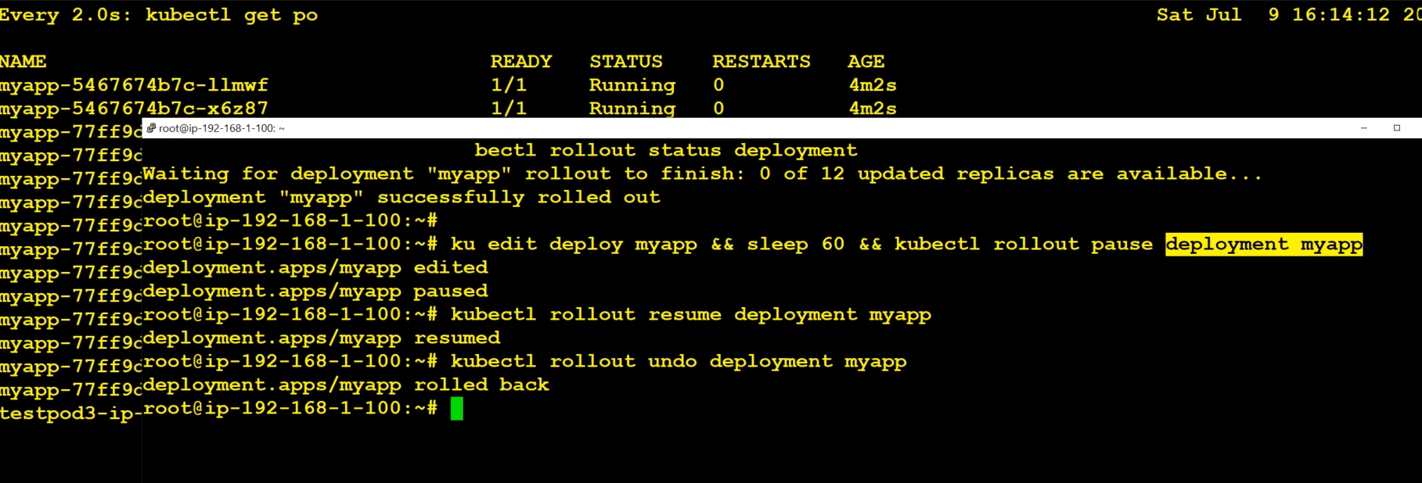

To rollout, we can do undo

**Imperative way:**

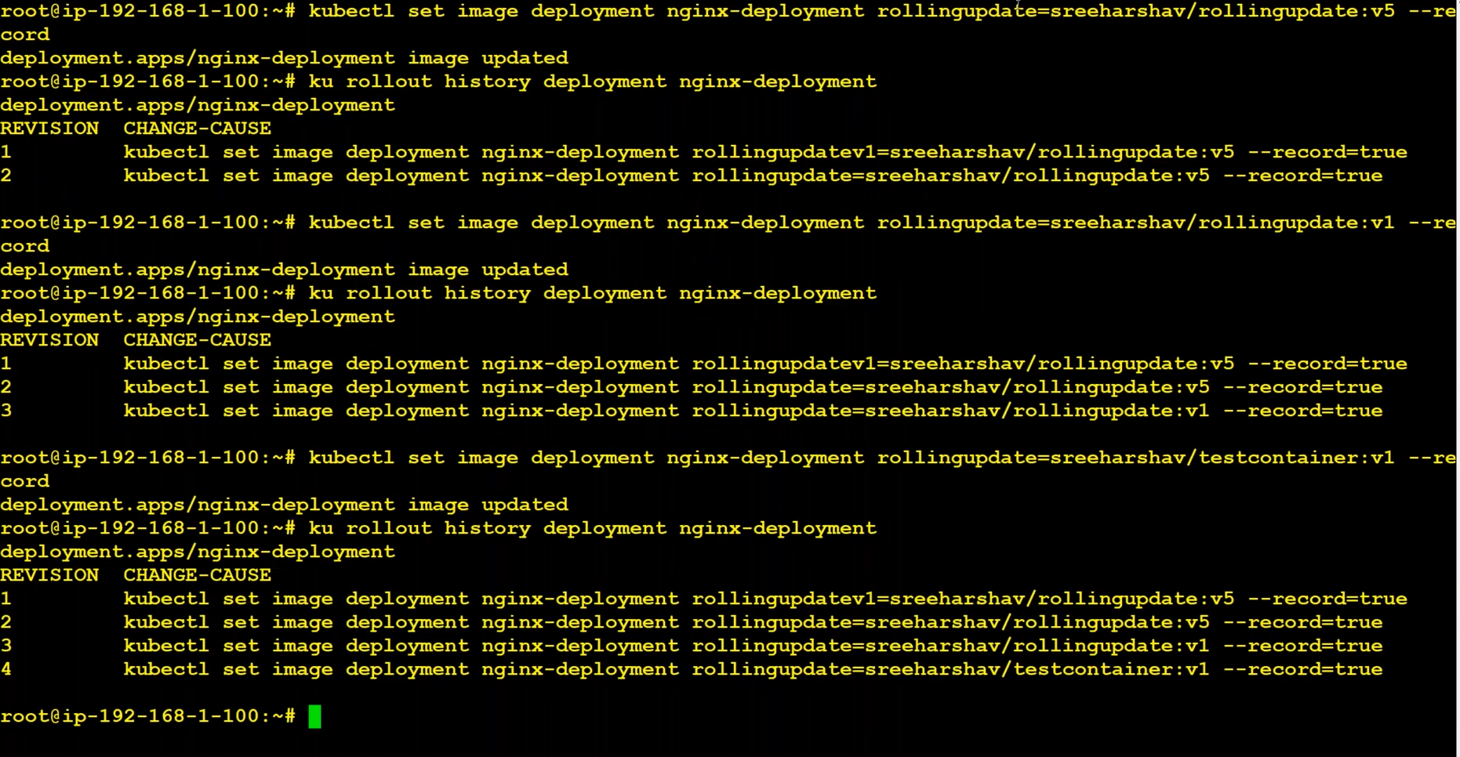

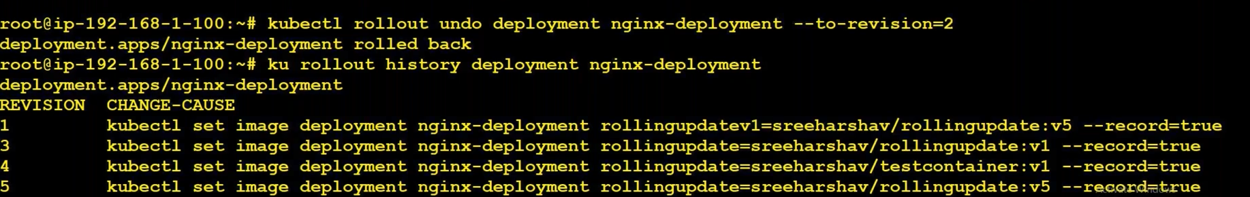

Replicaset : deployment changes (like image change) not be rolled out automatically

Deploymnets: any changes rolled out automatically.

Cordon vs drain :

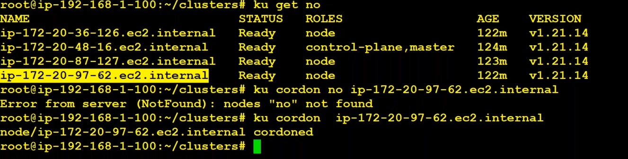

Cordon means if we increase the pods/replicas, they will not run on cordoned node/server. New pods/replicas will not run on cordoned node/server. It contains the pods/replicas that exists before cordoning.

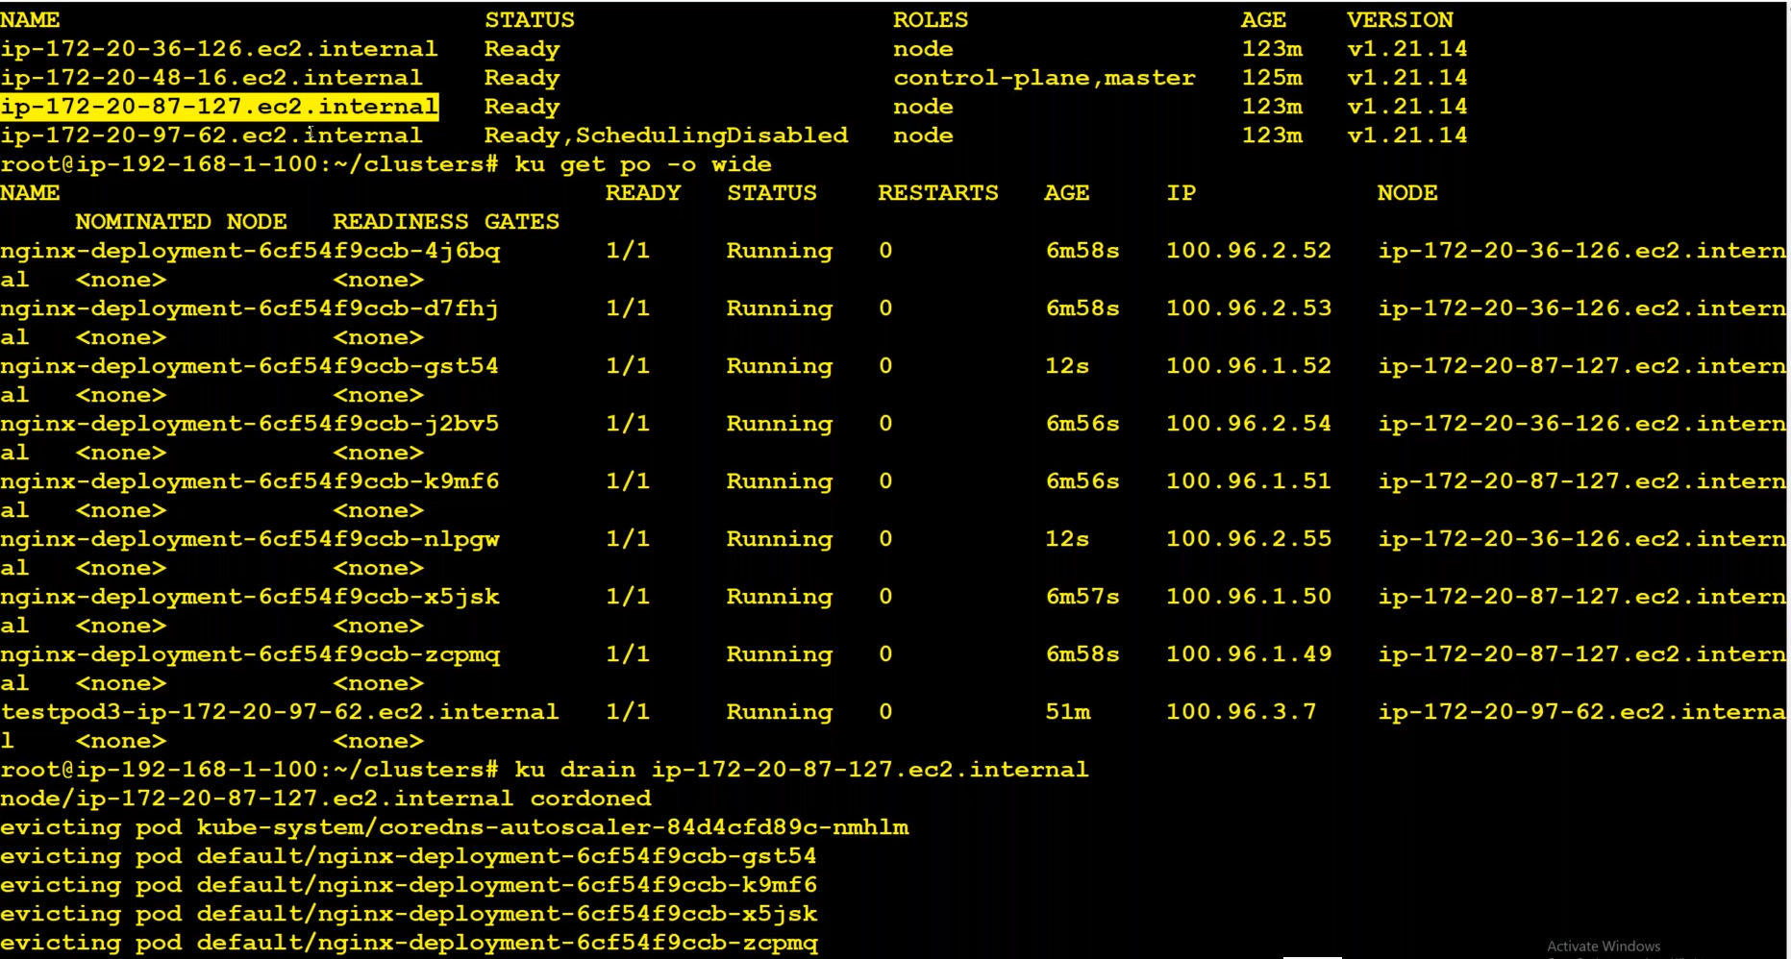

Drain removes all the pods/replicas which are running on the node/server. Removed pods/replicas would run on the other nods/servers. It removes all the pods and will not allow new pods/replicas.

PodDisruptionBudget :

We could have PodDisruptionBudget on deployment. If we try to drain all the worker_nodes/server, it will not allow us. It will show “***violate the pods disruption budget”***.

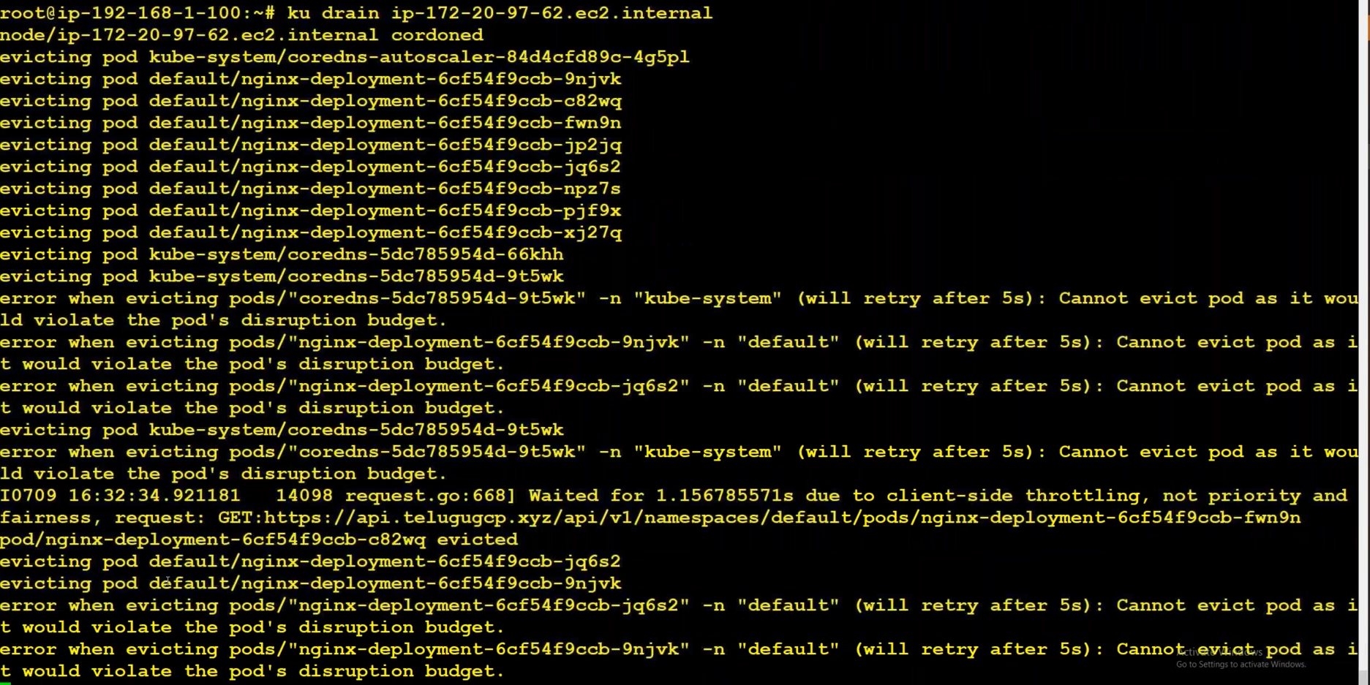

apiVersion: policy/v1

kind: PodDisruptionBudget

metadata:

name: nginx-deployment-pdb

spec:

minAvailable: 2

selector:

matchLabels:

app: nginx-deployment